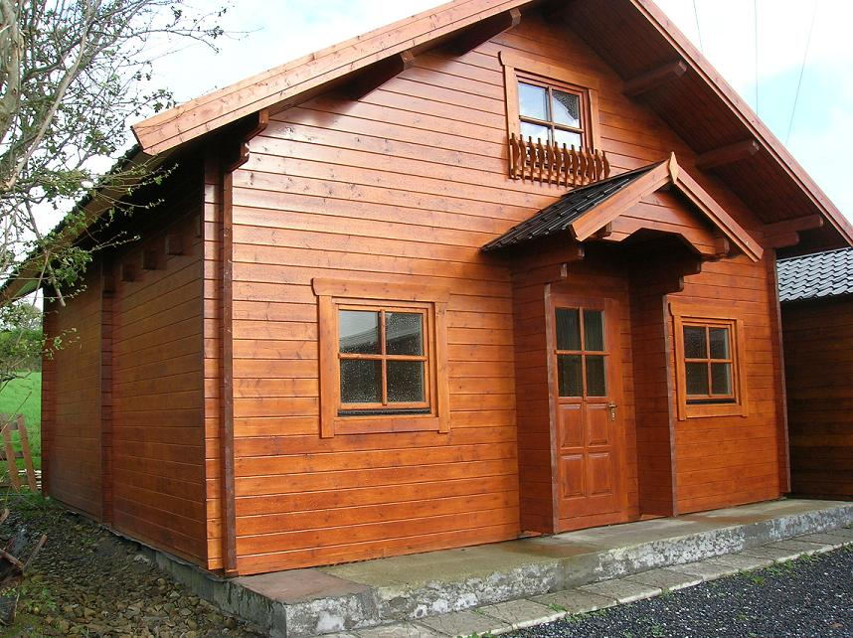 | 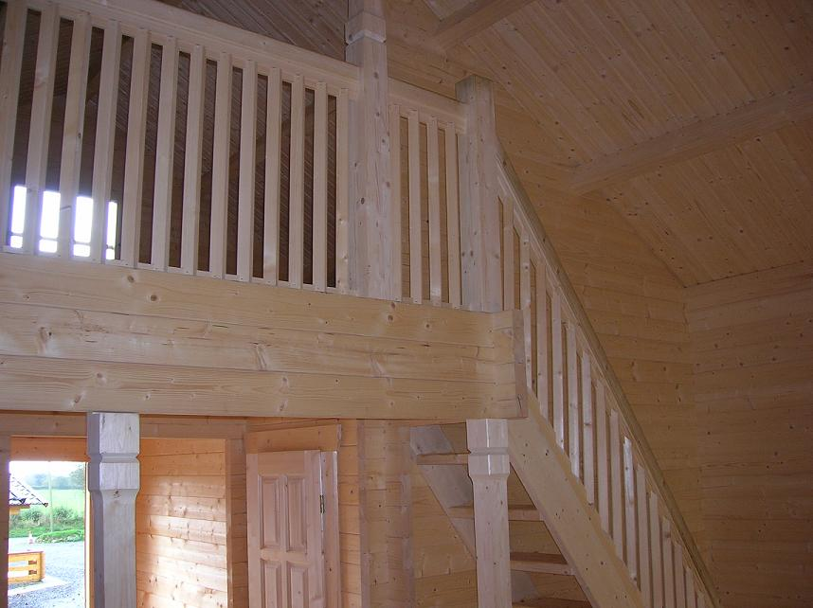
 | 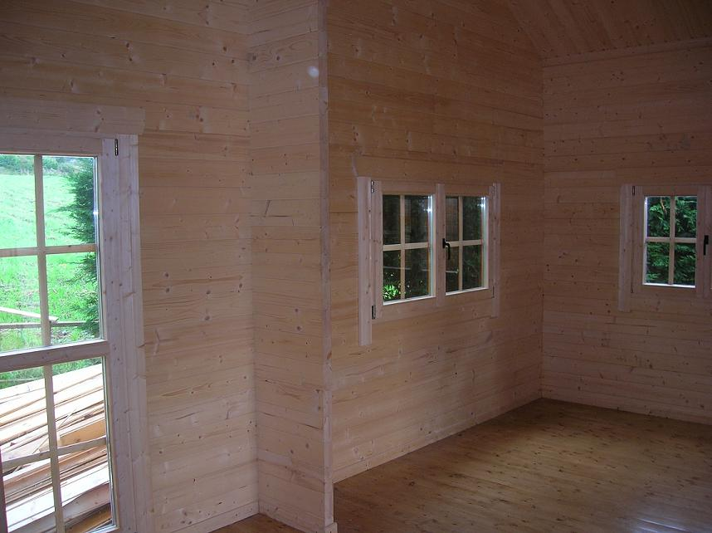
Ulmenfeld 6.20 x 6.45 m - £11,354
Roof projection: Front 0.70 m
Back 0.60 m
Side 0.60 m

Consisting of:

Walls: 60 mm walls with double tongue and groove
Floor Timber: 20 mm – tongue and groove
Roof Timber: 20 mm – tongue and groove
Effective area: 57 m²
Eves height: 2.86 m
Ridge height: 4.61 m
Door: 1 door 100/200, half glazed
2 doors 70/196
1 Terrace door 140/200
Window: 1 window 150/94
4 windows 100/94
1 window 70/94
Stairs: Spruce stairs with railing.

Extras:

Shutters: £676
95mm walls instead of 60mm: Call for price
Roof tiles Call for price
Roof structure for shingle roofing: For up to 10 cm insulation £435

